INNOVA JUNIOR COLLEGE
JC 2 PRELIMINARY EXAMINATION 2
in preparation for General Certificate of Education Advanced Level
Higher 2

CANDIDATE
NAME

CLASS INDEX NUMBER

BIOLOGY  Paper 3 | 9648/03  17 September 2010  2 hours

READ THESE INSTRUCTIONS FIRST

Write your name and class on all the work you hand in.
Write in dark blue or black pen on both sides of the paper.
You may use a soft pencil for any diagrams, graphs or rough working.
Do not use staples, paper clips, highlighters, glue or correction fluid.

Answer all questions.

The number of marks is given in the brackets [ ] at the end of each question or part question.

For Examiner’s Use
Section A
1 | 16
2 | 13
3 | 11
4 | 12
5 | 20
Total | 72

This document consists of 11 printed pages.
 | Innova Junior College | [Turn over

Section A
Answer all questions

1 | Confusion arising from babies being mixed up in maternity wards is common in less developed countries. Couples may be raising a child that is totally unrelated to them for many months before they discovered phenotypic characteristics that are not possible to be inherited from them.  The identification of parentage is often done through genetic fingerprinting whereby restriction fragment length polymorphisms (RFLPs) are often revealed through Southern blotting.  The most common method is to characterise the variable number of tandem repeats (VNTRs) in the individuals involved as VNTRs are inherited.
 | (a) | Explain what is meant by tandem repeats.
 |  |  | [1]
In one such case, chromosome 13 was isolated from the DNA samples that were obtained from 3 couples who had their babies mixed up by a careless nurse. DNA was also obtained from the 3 babies for comparative analysis.

The DNA samples were subjected to Polymerase Chain Reaction (PCR) before analysis. Fig. 1.1 shows the temperature graph obtained from a PCR cycle.

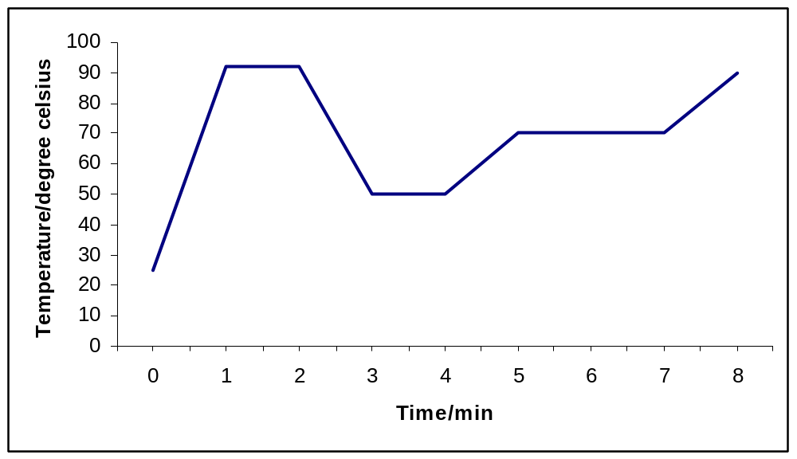
Temperature / ºC

Fig. 1.1

 | (b) | With reference to Fig. 1.1, account for the observed plateaus in temperature changes.
 |  |  | [6]
Fig. 1.2 shows a segment of chromosome 13 with 5' TTAGGAT 3' as the repeating unit and n is the number of repeats.

Fig 1.2

Fig. 1.3 shows the results of the autoradiograph obtained from the DNA analysis of the 3 couples and their babies.

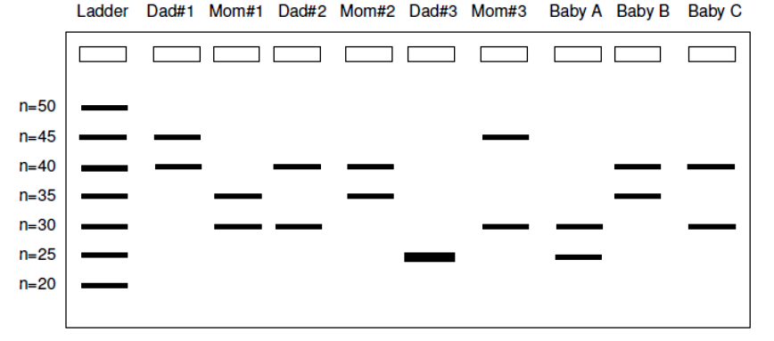

Fig. 1.3

 | (c) | With reference to Fig. 1.2 and 1.3,
 | (i) | state the purpose of the DNA ladder;
 |  |  | [1]
 | (ii) | explain why some bands are nearer to the wells of the agarose gel;
 |  |  | [3]
 | (iii) | explain why there is only a single band in Dad#3.
 |  |  | [1]
 | (iv) | assuming faithful partners, conclude the parentage relationships for Baby A, B and C.
 |  |  | [3]
 | (v) | suggest an improvement to the procedure to obtain more accurate results.
 |  |  | [1]
 |  | [Total: 16]

2 | Gene therapy can be used to treat diseases such as cystic fibrosis by delivering normal genes into cells. However, very different strategies of gene therapy are used to treat cancer.  In what is called 'suicide therapy', a gene such as the herpes simplex virus thymidine kinase gene (HSV-TK) is transferred to tumour cells. The enzyme phosphorylates the nucleoside thymidine. The HSV-TK gene is not normally found in the human body.  After building up high levels of TK activity in the tumour after several rounds of gene therapy, ganciclovir, a base analog inactive in normal cells, is given to the patient. In the presence of HSV-TK, ganciclovir is converted from a non-toxic prodrug to its active phosphorylated form, killing the tumour cells by disrupting DNA synthesis.  Table 2 shows the effect of HSV-TK and ganciclovir levels on tumour cells.  Table 2
  HSV-TK levels / arbitrary units | Ganciclovir dosage / arbitrary units | Percentage cell death in tumour / %
  5 | 20 | 35
  10 | 20 | 38
  10 | 80 | 56
 | (a) | Explain what is meant by gene therapy.
 |  |  | [1]
 | (b) | Using information from the passage, suggest how HSV-TK and ganciclovir work together to kill cancer cells.
 |  |  | [3]
 | (c)(i) | Explain why gene therapy for cancer cannot take the same approach as that of diseases like cystic fibrosis.
 |  |  | [2]
 | (ii) | State one advantage of using 'suicide gene therapy' compared to traditional forms of cancer therapy like chemotherapy.
 |  |  | [1]
 | (d) | With reference to Table 2, explain the effects of HSV-TK and ganciclovir on tumour cells.
 |  |  | [2]
 | (e) | Genes delivered using non-viral vectors often experience less target tissue specificity and transient gene expression.
 | (i) | Explain why delivering the HSV-TK gene using non-viral vectors does not limit the efficacy of the treatment.
 |  |  | [2]
 | (ii) | Suggest two reasons why gene expression is often transient when using non-viral vectors.
 |  |  | [2]
 |  | [Total: 13]

3 | The carp is a freshwater fish which became a pest when it was introduced to Australia in the 1970's. The authorities have traditionally attempted to control carp numbers by physically excluding carp from suitable breeding sites.  Recently, scientists are trying to control the carp by using antisense gene technology. A transgene inserted into carp embryos prevents the production of an enzyme, aromatase. The enzyme is responsible for a key step in the biosynthesis of oestrogens, a female hormone. The presence of the transgene causes female embryos to develop into males.  The concept is that large numbers of carp containing the transgene would be bred in hatcheries and released into the wild. Over time, this will result in the reduction of the carp population.  Fig. 3 shows section of the aromatase gene and the inserted transgene.  5' … TGGCTA … 3' 5' … TAGCCA … 3'  aromatase gene transgene  Fig. 3
 | (a) | Suggest why the carp became a pest when it was introduced into Australia.
 |  |  | [1]
 | (b)(i) | With reference to Fig. 3, explain how the insertion of the transgene causes carp female embryos to develop into males.
 |  |  | [3]
 | (ii) | Describe how genetically modified carp embryos can be obtained.
 |  |  | [2]
 | (iii) | Suggest why several genetically modified carp embryos still developed into female adults.
 |  |  | [1]
 | (c) | Explain how releasing genetically modified carp would result in a reduction in wild carp population over time.
 |  |  | [2]
 | (d) | The use of gene technology in controlling carp population has advantages over current methods but has also raised concerns. State
 | (i) | one advantage;
 |  |  | [1]
 | (ii) | one concern.
 |  |  | [1]
 |  | [Total: 11]

4 | Planning  You are required to plan, but not carry out, an investigation into the effect of intensity of light on the rate of photosynthesis.  Photosynthetic rates in plants are affected by both quantity and quality of light. The light intensity and wavelength of light optimum for photosynthesis varies between plant species and even cultivars.  Your planning must be based on the assumption that you have been provided with the following equipment and materials:  - photosynthetic plant (aquatic or terrestrial)  - sharp knife and white tile for cutting  - NaHCO₃  - table lamp (60W)  - distilled water  - metre rule  - plastacine  - conical flasks  - filter funnel  - burette  - rubber tubing  - a variety of different sized beakers, measuring cylinders, syringes and pipettes for measuring volumes  Your plan should have a clear and helpful structure to include:  - an explanation of the theory to support your practical procedure  - a description of the method used, including the scientific reasoning behind the method and any recommended safety measures  - an explanation of the dependent and independent variables involved  - relevant, clearly labelled diagrams  - how you will record your results and ensure that they are as accurate and reliable as possible  - proposed layout of results table and graphs with clear headings and labels  - the correct use of technical and scientific terms  [Total: 12]

5 | Write your answers on the separate answer paper provided.  Your answer:  - should be illustrated by large, clearly labelled diagrams, where appropriate.  - should be in continuous prose, where appropriate.  - must be set out in section (a), (b) etc., as indicated in the question.
 | (a) | Explain how gel electrophoresis is used to analyse DNA. [6]
 | (b) | Outline the process of nucleic acid hybridisation and explain how it can be used to detect and analyse restriction fragment length polymorphism (RFLP). [5]
 | (c) | Explain how RFLP analysis facilitated the process of linkage mapping, diseases detection and DNA fingerprinting. [9]
 |  | [Total: 20]

